Create a data pipeline in the data factory

Go to azure home

<https://portal.azure.com/#home>

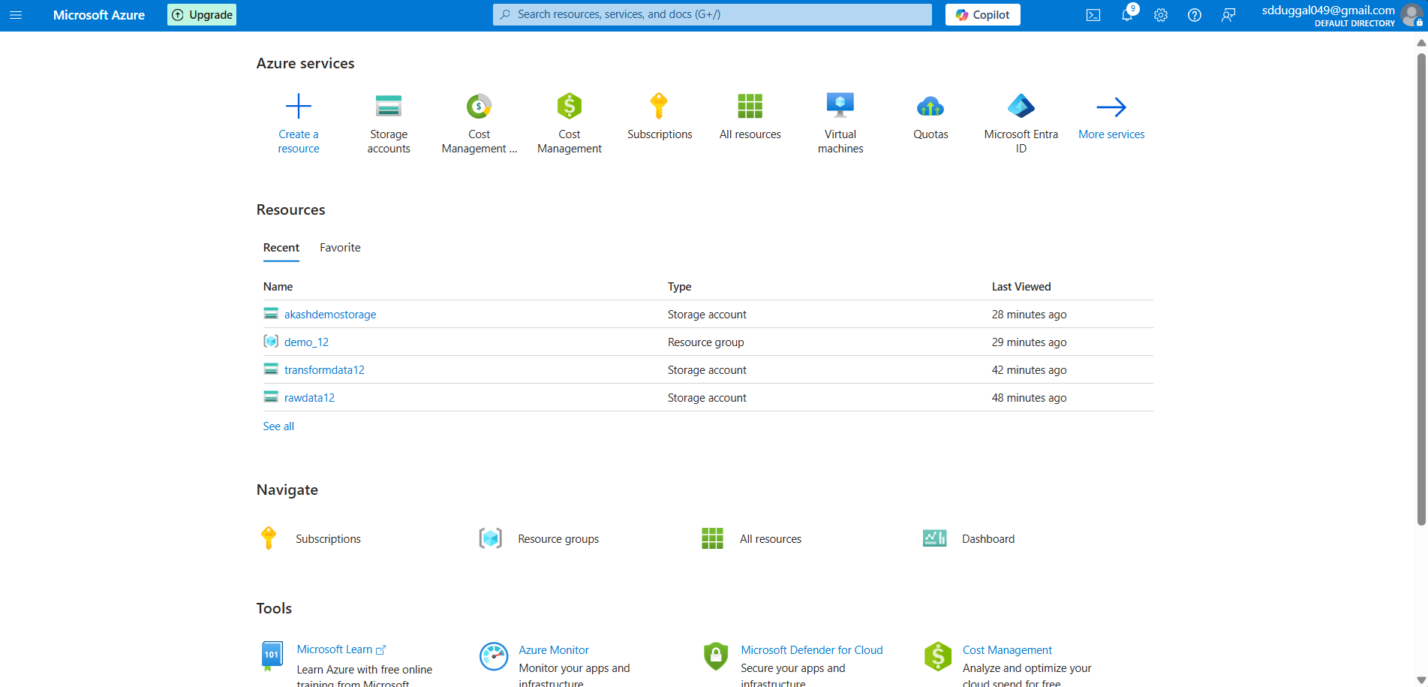

Search for data factory

After clicking on data factory, you will land up here

Now we will create a data factory for data pipeline creation

Now just select the resource group you have created while creating the storage account   
then give name to data factory

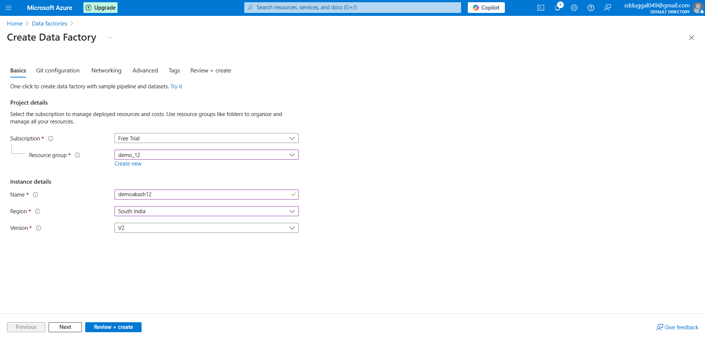

Keep other things as it is

And click on review+ create

It will take 2 minutes to create data factory

Once it’s done you will get this screen

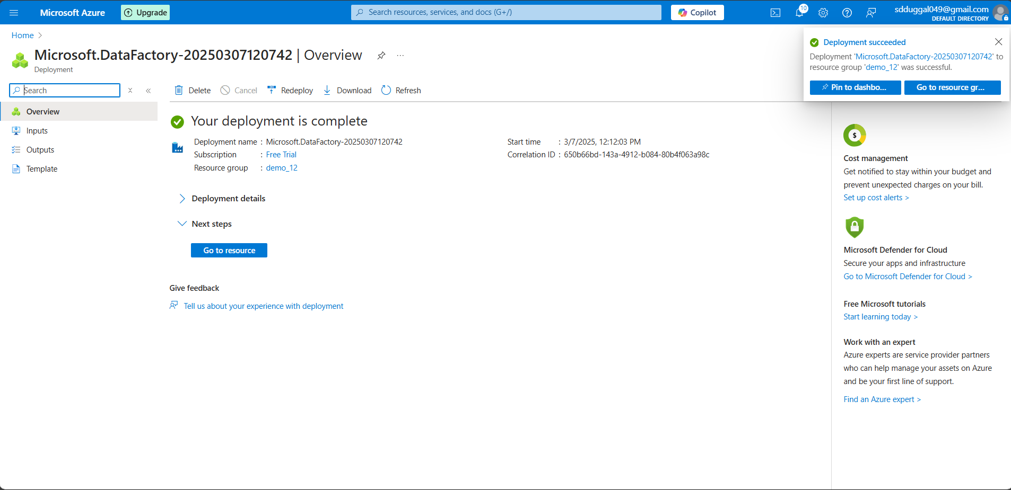

Then go to data factory you have created

Click on launch studio

You will land up in data factory console

Create a pipeline called data_ingestion

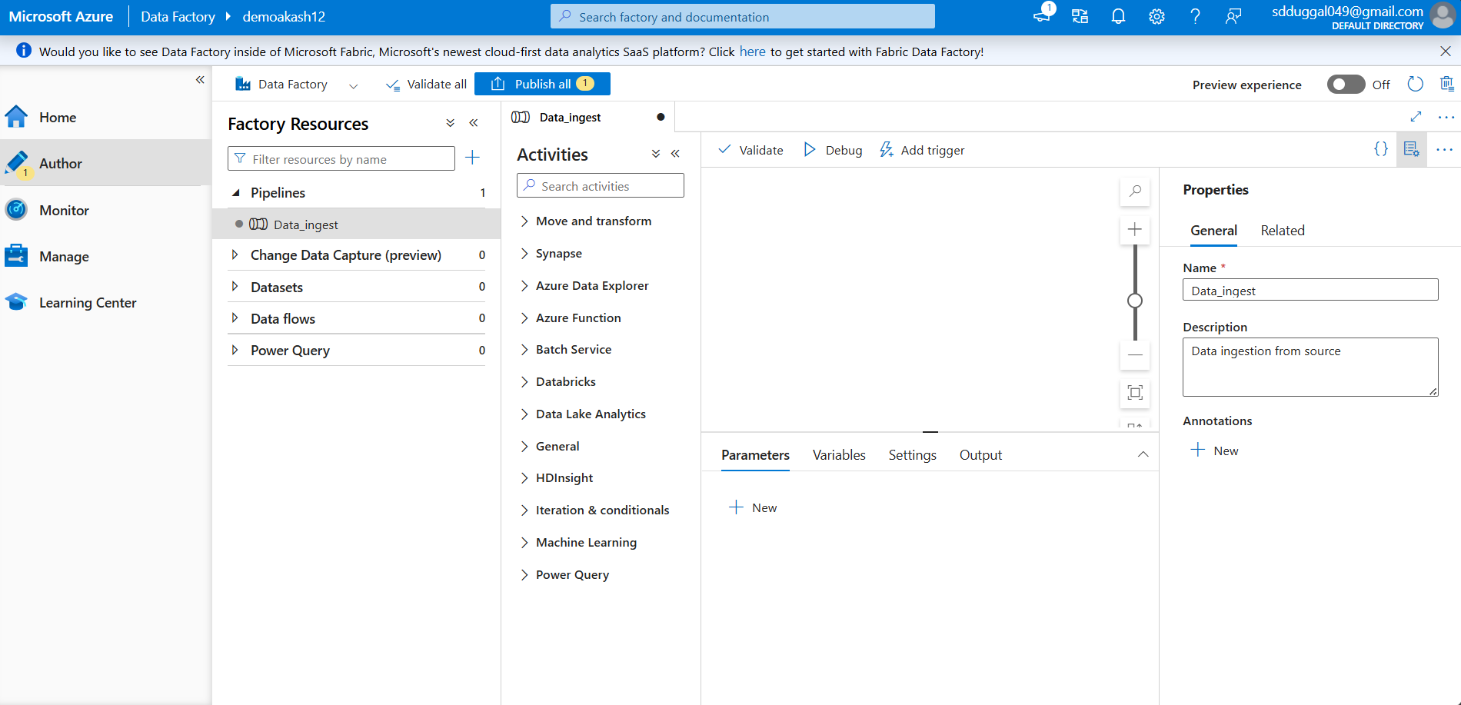

In that pipeline   
go to Move and Transform 🡪 copy data  
Just drag the copy data to workplace

In the General

We have to name the activities  
then add little bit description

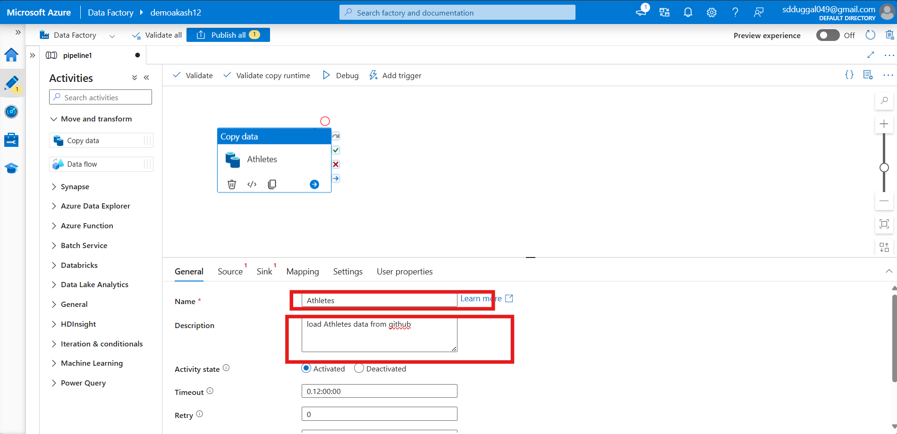

Keep other setting as it is

In the General

Click on new

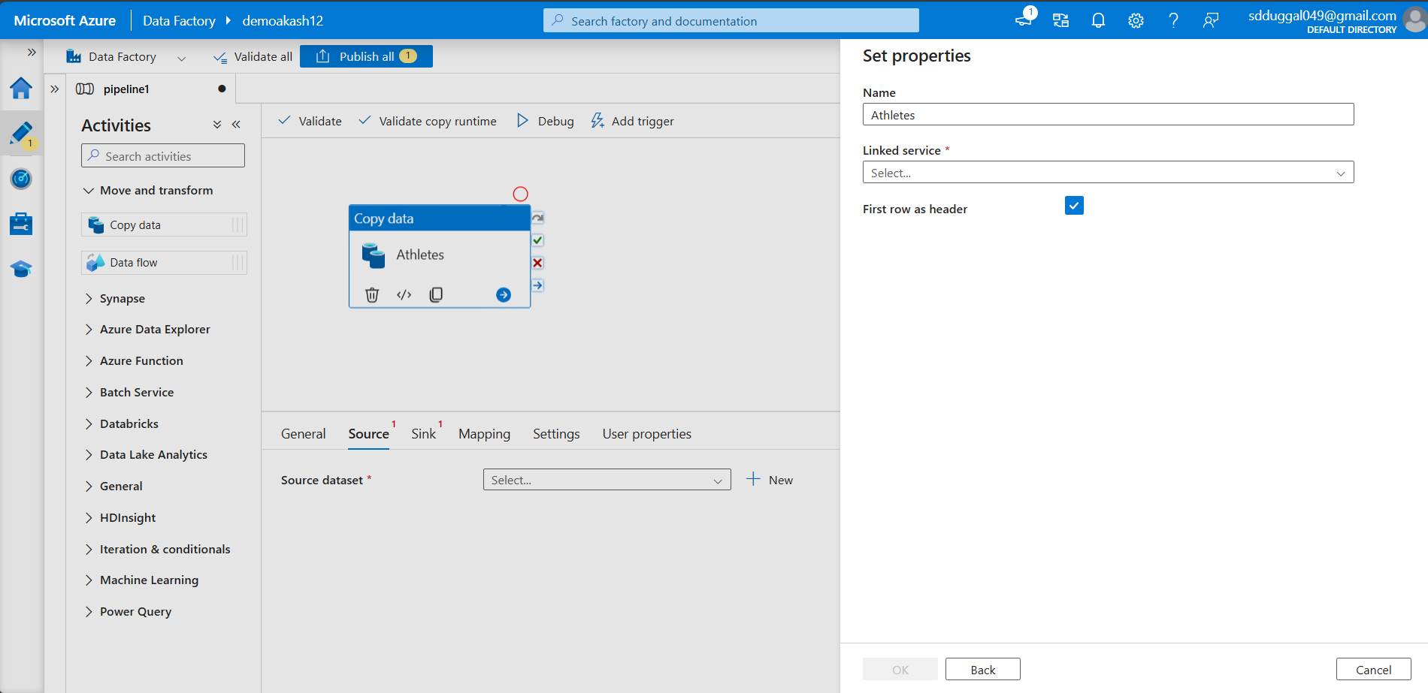

Now we will create a link between  
Github to storage account

For that we have to create new linked service

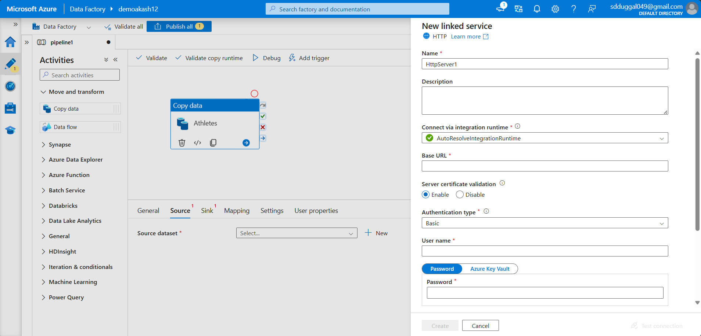

In that we have added

Name

Description

Base url

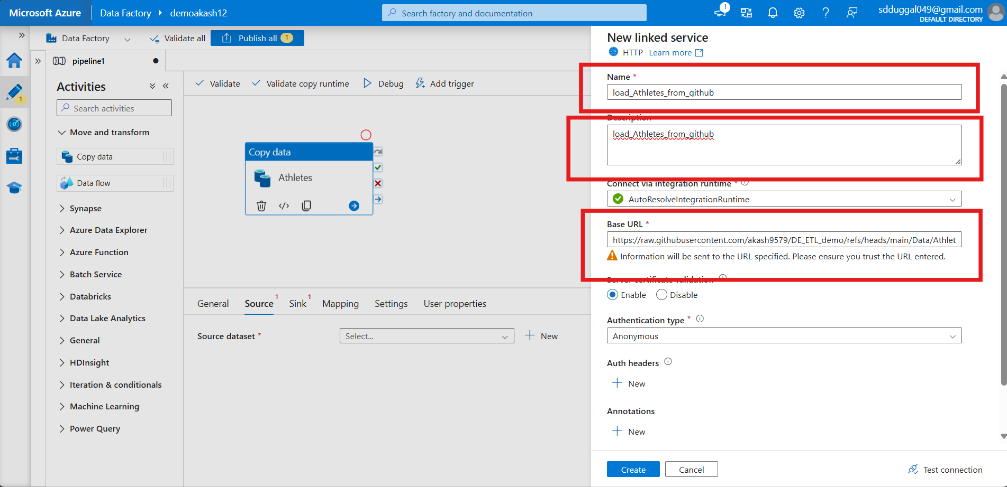

Click on create

Now linking service as created

Click on okay

Now we have created a link for the source

In the Sink

next we have to create a link for the destination

Create a new link for the destination

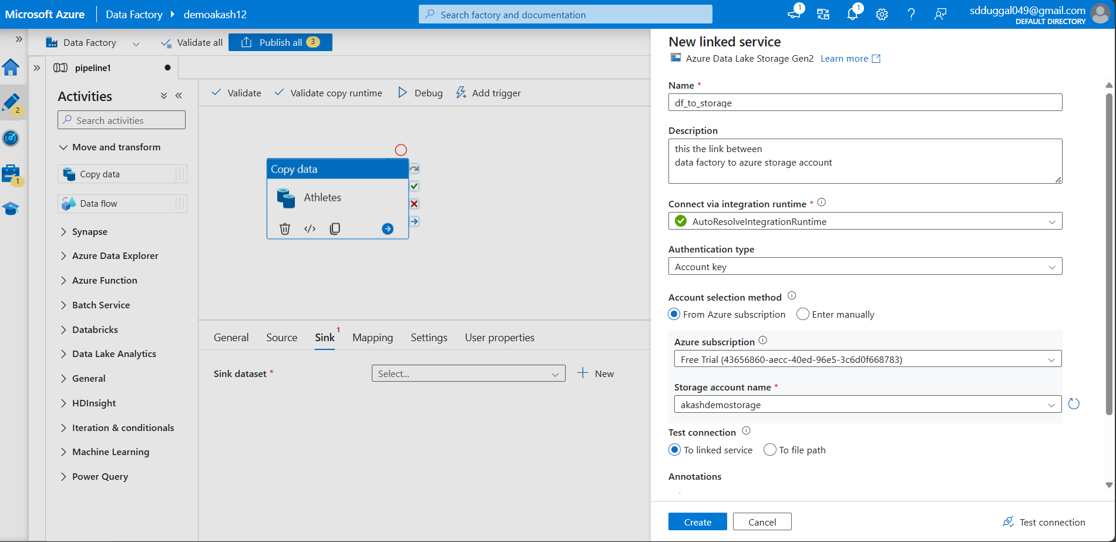

Now we have to mention the file path

In which we have to store the file

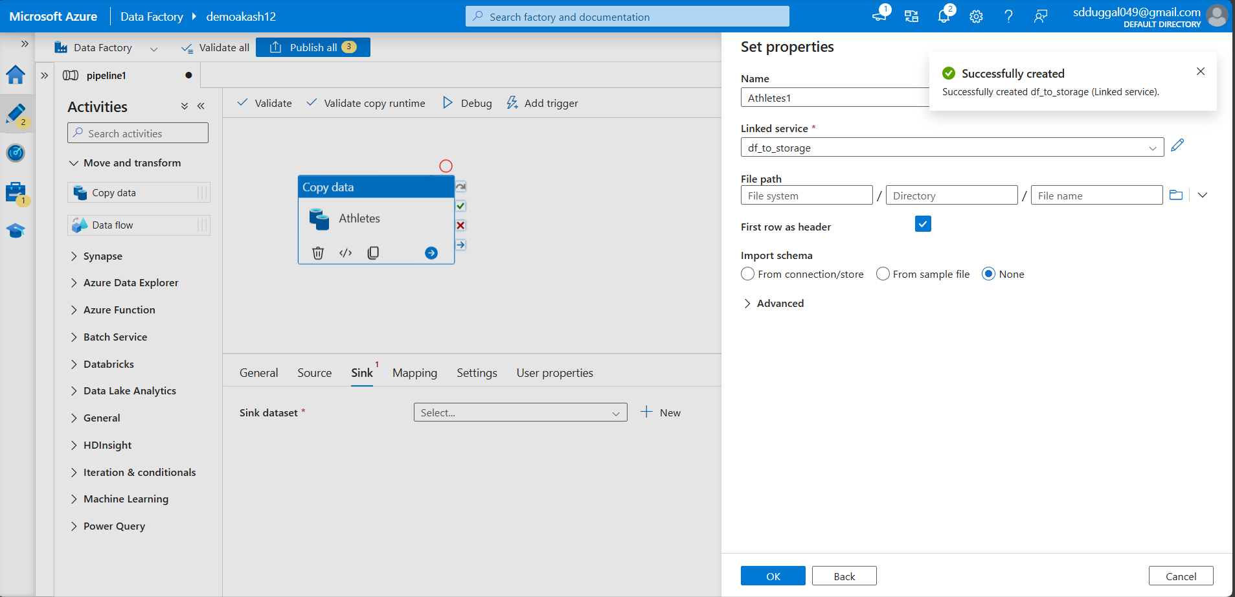

Now our activity is ready   
we have updated the source

We have updated the destination (sink)

Now run this activity

First validated it

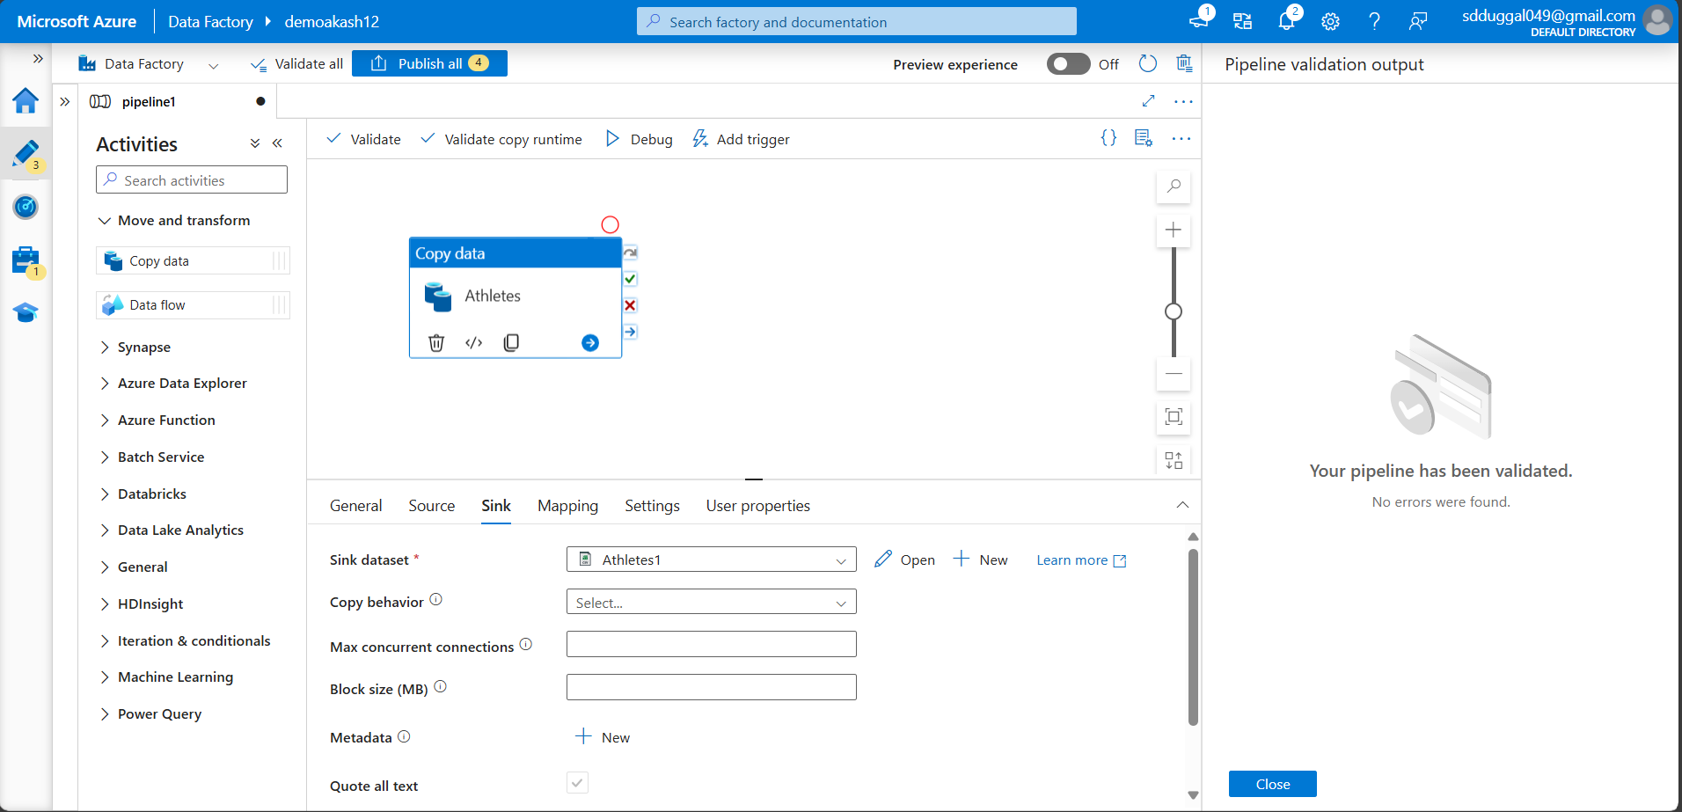

After validation debug it

It will take a while to debug

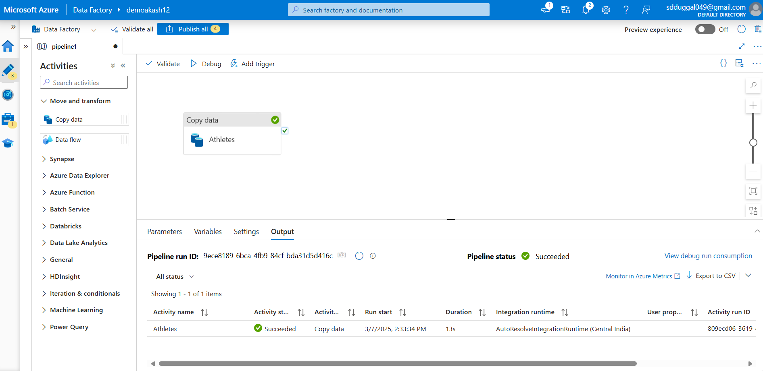

Small task

Load the transformation.csv file through pipeline